**The role of ICE servers**

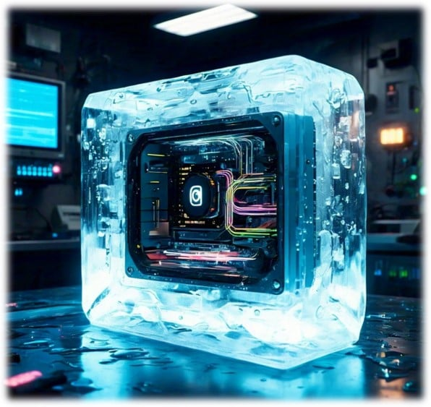

While tools like **ipconfig** and **netstat** offer valuable insights into network configurations, they are just the starting point and often insufficient for WebRTC applications.

Each WebRTC connection also requires a unique port, and while it’s theoretically possible to manage this manually, this approach is impractical.

This is where **Interactive Connectivity Establishment (ICE)** servers become essential.

ICE servers facilitate NAT traversal. The ICE protocol addresses the challenges posed by NATs and firewalls through a process known as "ICE gathering," where devices exchange network addresses called ICE candidates.

But let’s not get ahead of ourselves.

Let’s move on, one step at a time.